PROJECT REPORT

1.INTRODUCTION

1.1 Overview

Property management is the operation ,control and oversight of a real estate as used in its most broad terms. Management indicates a need to be cared for, monitored and accountability given for its useful life and condition. This is much akin to the role of management in any business.

1.2 Purpose

day to day repairs

ongoing maintenance

security

upkeep of properties

2.PROBLEM DEFINITION AND DESIGN THINKING

2.1Emphathy map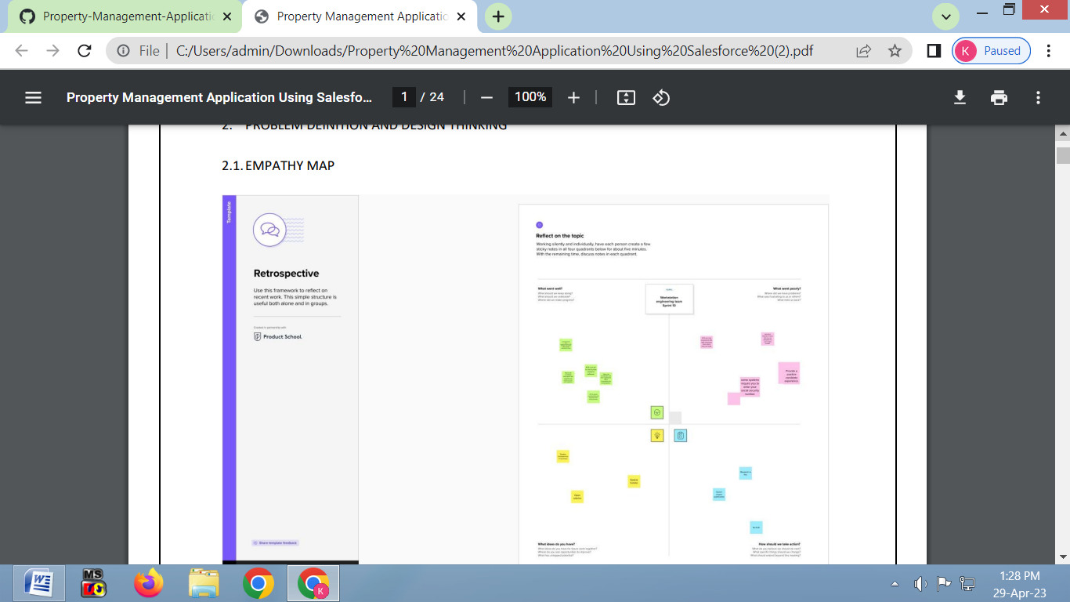

2.2 Ideation and Brainstorming Map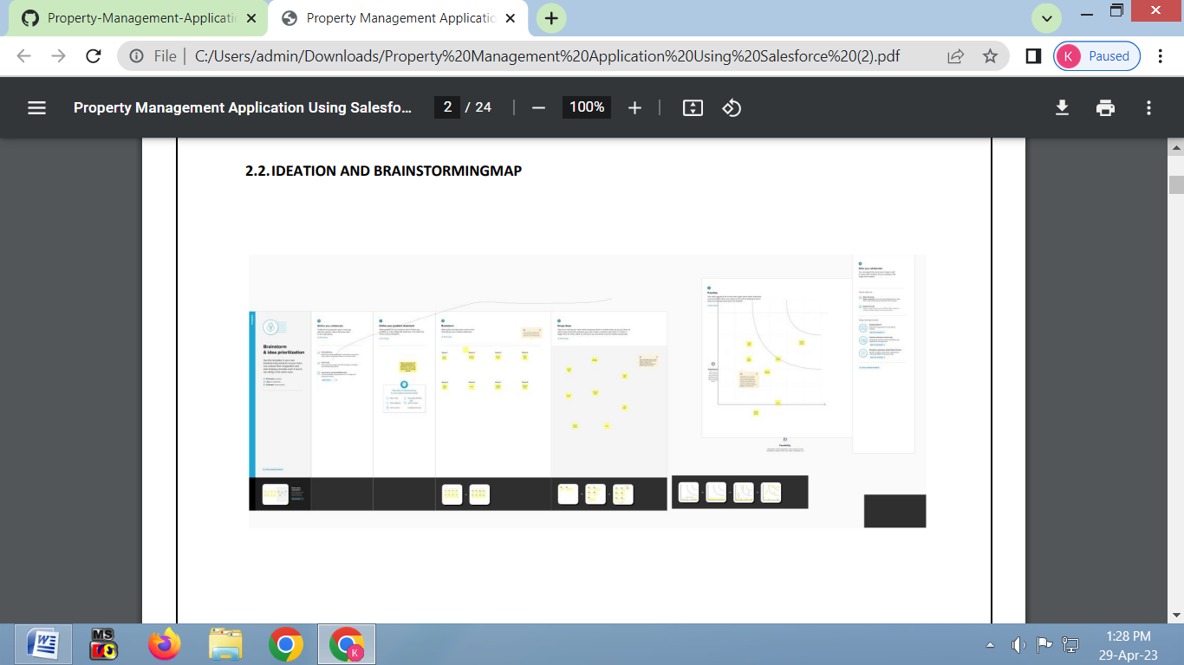

3.Result

DATA MODEL

|  |  |  |  |  |  |  |  |
| --- | --- | --- | --- | --- | --- | --- | --- |
| Standard object | |  |  | | --- | --- | | Field lable | Data Type | | Users | Text | | Contracts | Text | |
| Custom Object | |  |  | | --- | --- | | Field Name | Data Type | | Buy | Discount | | Rent | City | |

3.2 Activity & Screenshot

First we need to create new custom object that related to our topic, and type the other details too.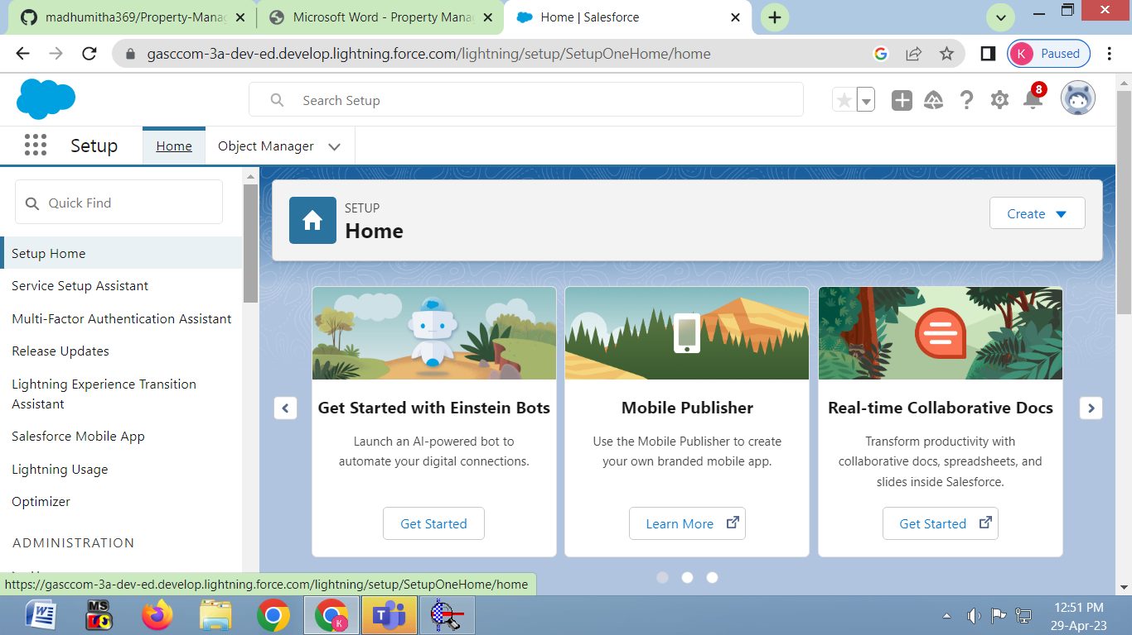

Activity 2: Create Object Buy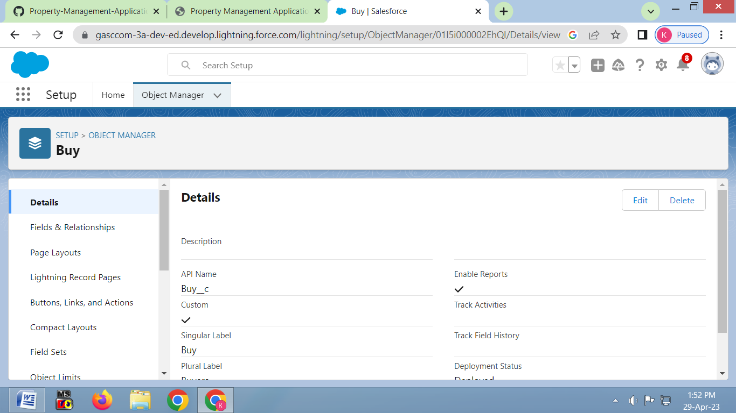

Activity 3: Create Object Rent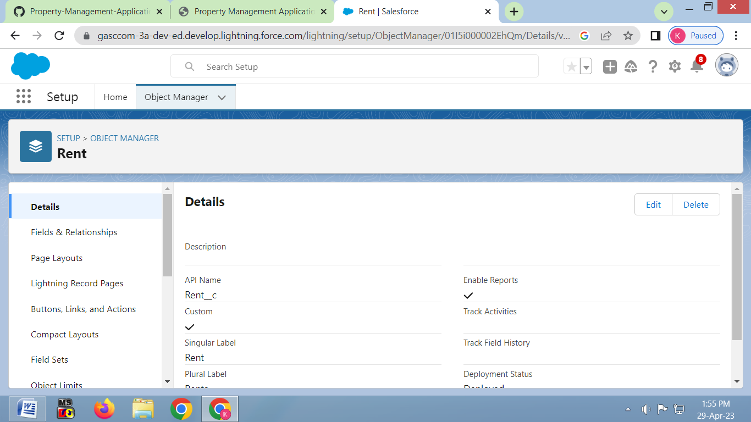

Activity 4: Create Object loan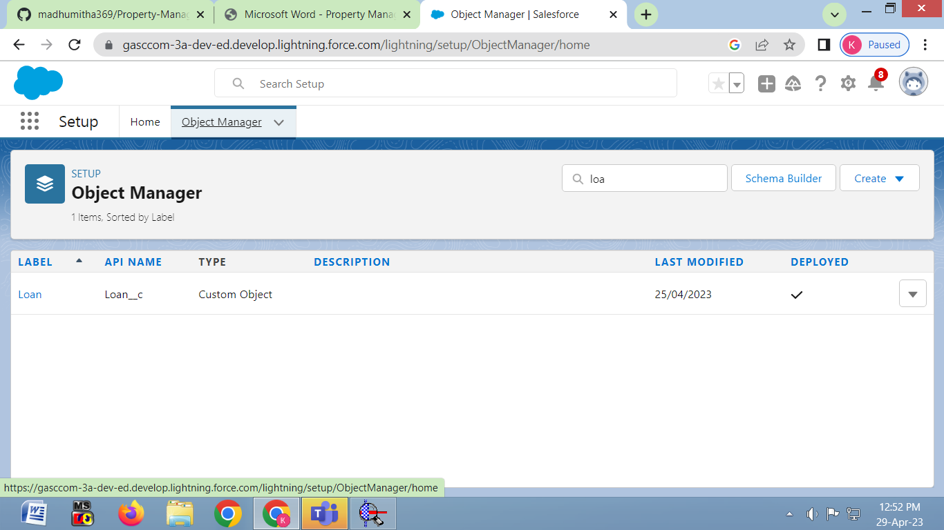

Milestone 3: Tab

Activity 1: Create the lightning Tab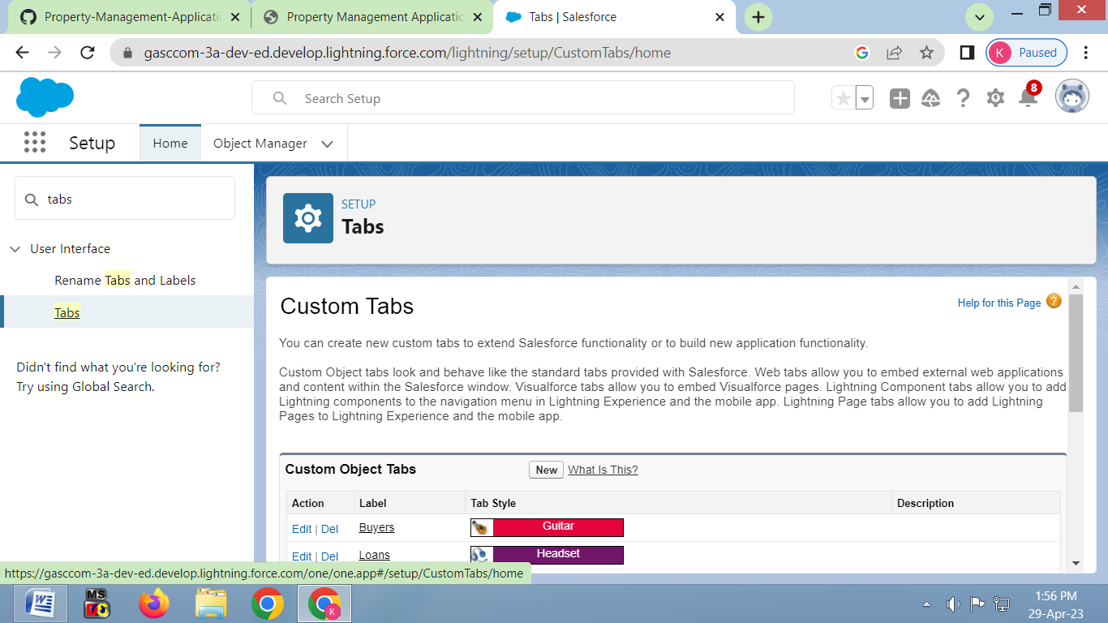

Activity 2: Create a Tab (Loan)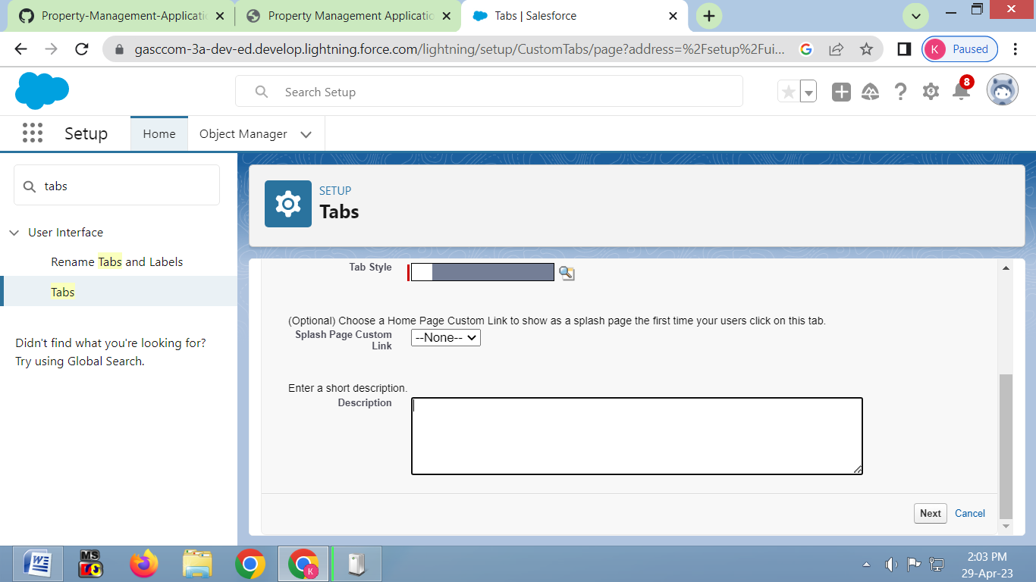

Activity 3: Create a Tab (Rent)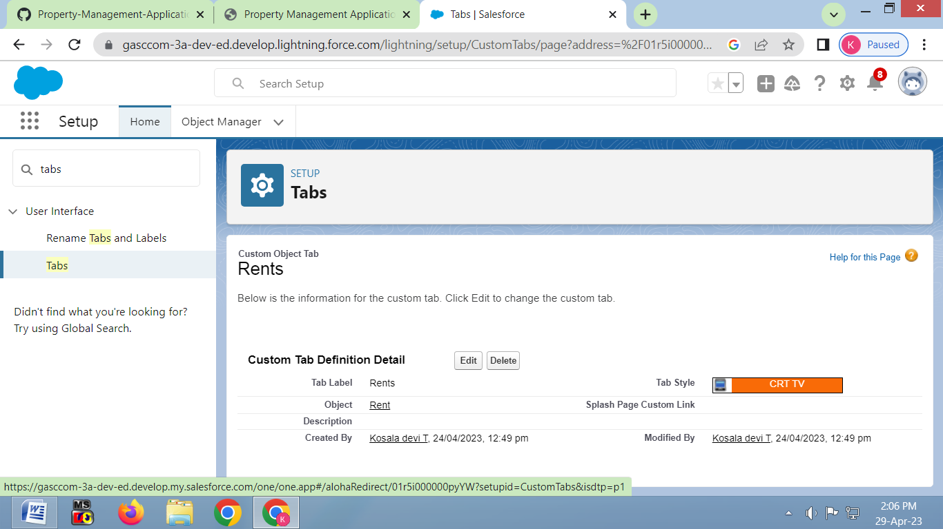

Milestone 4: The Lightning App

Activity 1: Create the lightning App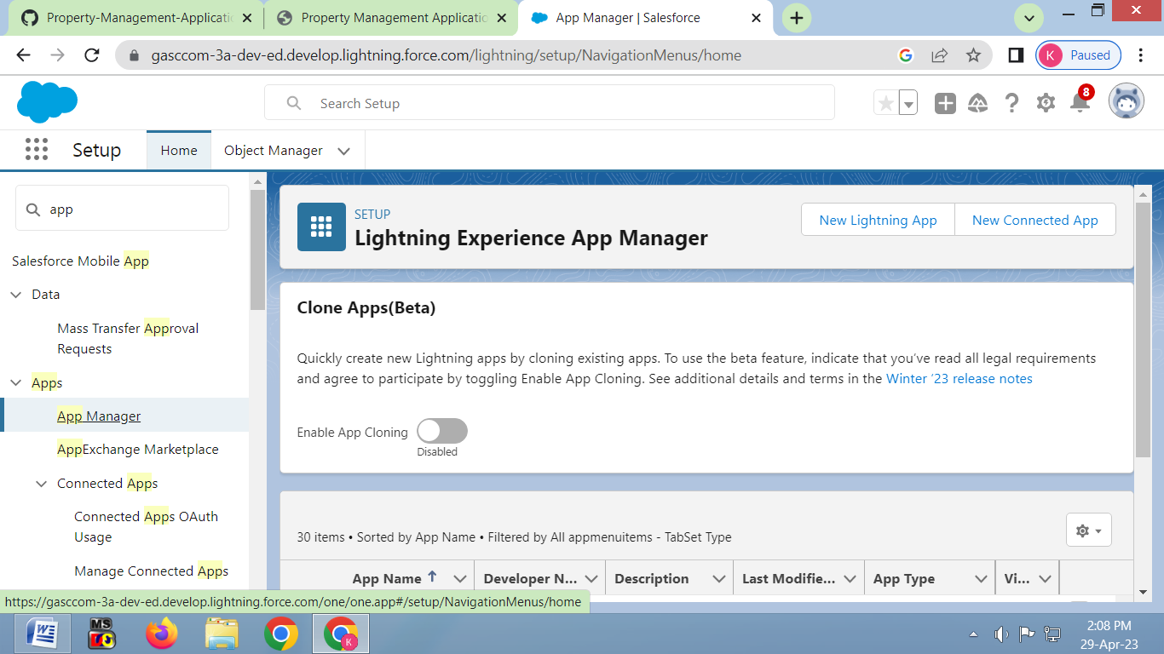

Milestone 5: Fields

Activity:1 Create field for Loan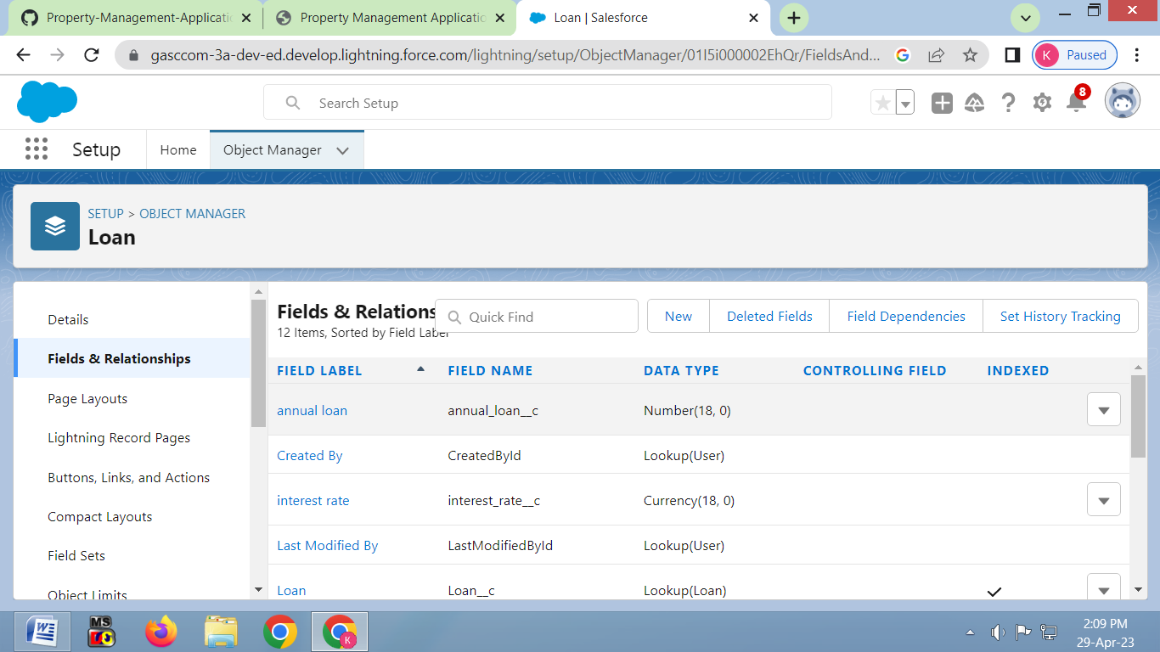

Activity 2: Create field for Rent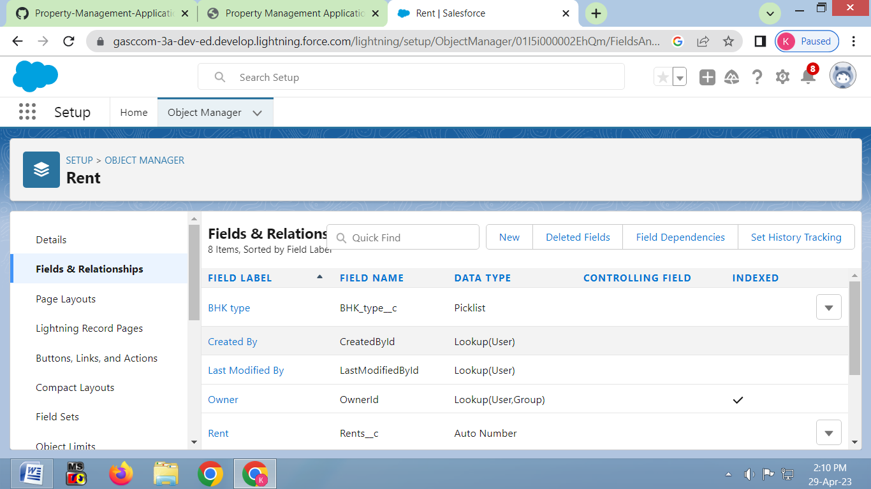

Activity 3: Create the remaining field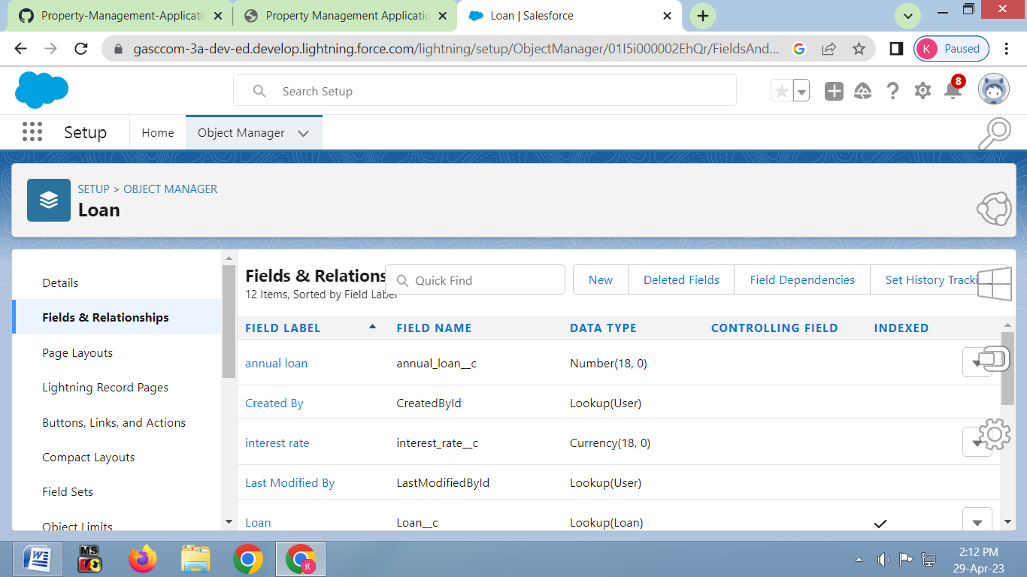

To create a Tab and to view the records in the object details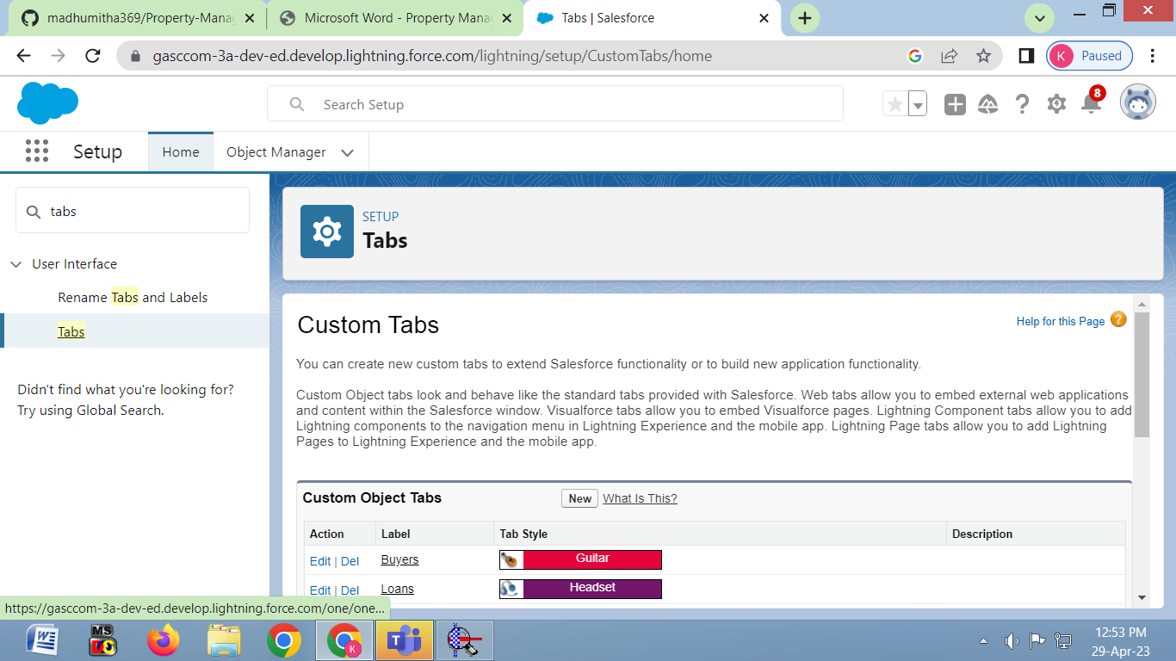

Object Manager should include this session with the valid details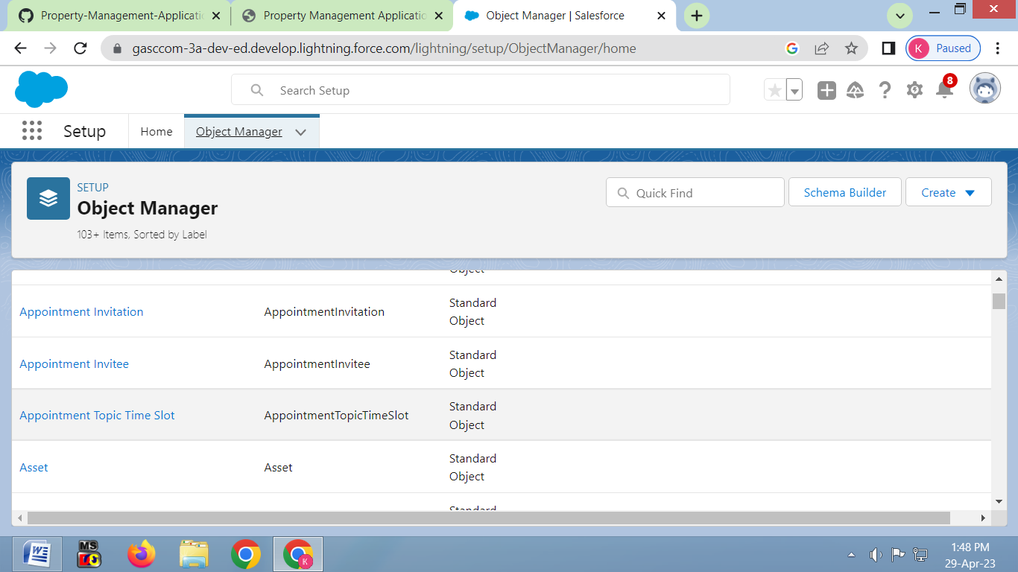

Finally, after completion those tasks ,we get the reports of our project and dashboard too.

4.Trailhead profile public URL

Team Leader- https://trailblazer.me/id/kosat4

Team member 1- <https://trailblazer.me/id/>aarya281

Team member 2-<https://trailblazer.me/id/>mmnivedha

Team member 3--<https://trailblazer.me/id/>nivec2

5.Advantages

Experience in the industry

Frees up your Time

Property Management Learn a lot about real estate

Easy entry

Professional Maintenance

Tenant sourcing and screening

Disadvantages

Costly

Oversight

Lack of involvement

Less direct control

Lower profitability

6.APPLICATION

Maintenance managementϖ

Managing chargesϖ

It is a software application for the operationsϖ of hospitality accommodations

Commercial residential rental properties

7.CONCLUSION

Transportation accessibility become greater contributor to the commercial value of a site.The applied language technologies should be encouraged to efficient services.Make informed decisions and build customer loyality

8.FUTURE SCOPE

The real estate sector is going to continue on its journey of long term growth

Continuous rise in GDP

Larger disposable incomes